Poise Dance Center

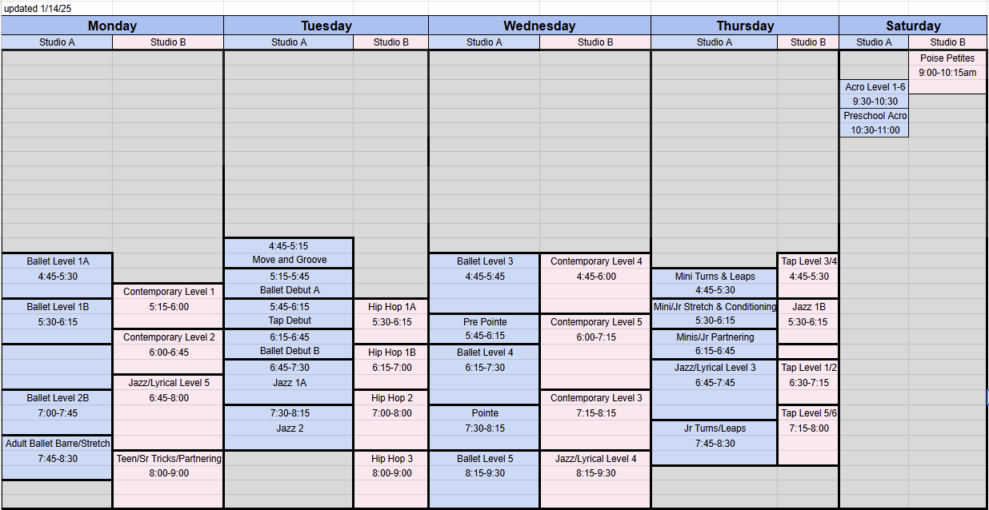Spring 2025 Class Schedule v.5 (as of 1-14-2025)

Please email our Recreational Director, Brianne Sendaj, with any questions related to placements, scheduling, or programming needs at [brianne@poisedance.org](mailto:brianne@poisedance.org).